Data Operations - Sorting

Definition
# Source: AI Source: Provided by: [Data Path: Persons Table -> ID Column: 1, Name_En Column: Motasem Essam] -> From: [ChatGPT] on [12/10/2025]
Sorting is the process of arranging data in a specific order based on one or more fields or criteria, such as alphabetical, numerical, or chronological order.
- Sorting makes data easier to analyze, read, and retrieve.

Key idea:
# Source: AI Source: Provided by: [Data Path: Persons Table -> ID Column: 1, Name_En Column: Motasem Essam] -> From: [ChatGPT] on [12/10/2025]
It’s like organizing books on a shelf by title or author so you can find them quickly.

Characteristics of Sorting
# Source: AI Source: Provided by: [Data Path: Persons Table -> ID Column: 1, Name_En Column: Motasem Essam] -> From: [ChatGPT] on [12/10/2025]
- Can sort data in ascending or descending order
- Works on single or multiple fields (e.g., Name, Score, Date)
- Often combined with retrieval queries or reports
- Makes comparison, analysis, and reporting easier
- Can be applied to databases, files, and spreadsheets

Example
# Source: AI Source: Provided by: [Data Path: Persons Table -> ID Column: 1, Name_En Column: Motasem Essam] -> From: [ChatGPT] on [12/10/2025]
A student database:
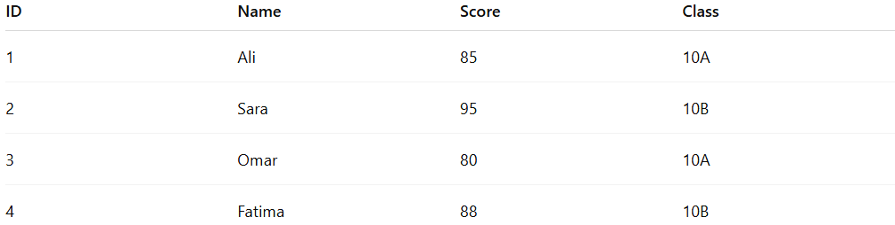
ID | Name | Score | Class
1 | Ali | 85 | 10A
2 | Sara | 95 | 10B
3 | Omar | 80 | 10A
4 | Fatima | 88 | 10B
- Sort by Score in descending order:
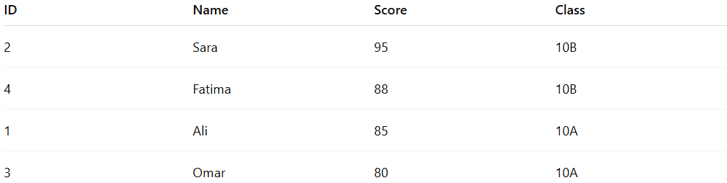
ID | Name | Score | Class
2 | Sara | 95 | 10B
4 | Fatima | 88 | 10B
1 | Ali | 85 | 10A
3 | Omar | 80 | 10A

Example Section
# Source: AI Source: Provided by: [Data Path: Persons Table -> ID Column: 1, Name_En Column: Motasem Essam] -> From: [ChatGPT] on [12/10/2025]
A teacher wants to rank students by their scores:
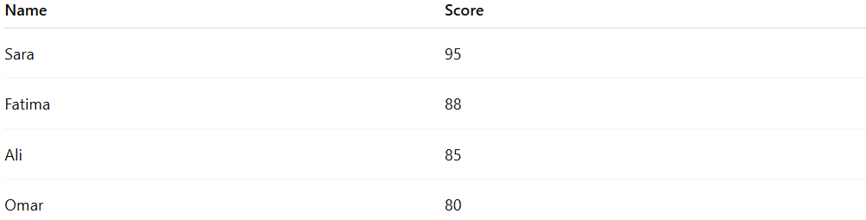
Name | Score
Sara | 95
Fatima | 88
Ali | 85
Omar | 80
- Sorting allows the teacher to quickly identify the top-performing students.
- This is sorting-based retrieval, improving clarity and analysis.

Advantages
# Source: AI Source: Provided by: [Data Path: Persons Table -> ID Column: 1, Name_En Column: Motasem Essam] -> From: [ChatGPT] on [12/10/2025]
- Makes data easier to read and interpret
- Supports quick analysis and reporting
- Can be combined with filters or queries
- Useful for ranking, trend detection, and decision-making

Disadvantages
# Source: AI Source: Provided by: [Data Path: Persons Table -> ID Column: 1, Name_En Column: Motasem Essam] -> From: [ChatGPT] on [12/10/2025]
- Sorting large datasets may take significant time and resources
- Incorrect sort criteria can mislead analysis
- Frequent sorting may affect performance in real-time systems
- May require additional memory or processing power for complex sorts

